1. **Design a Database for a company to Manage all its projects**.

* Company has diverse offices in several countries, which manage and co-ordinate the project of that country.
* Head office has a unique name, city, country, address, phone number and name of the director.
* Every head office manages a set of projects with Project code, title, project starting and end date, assigned budget and name of the person in-charge. One project is formed by the set of operations that can affect to several cities.
* We want to know what actions are realized in each city storing its name, country and number of inhabitants.

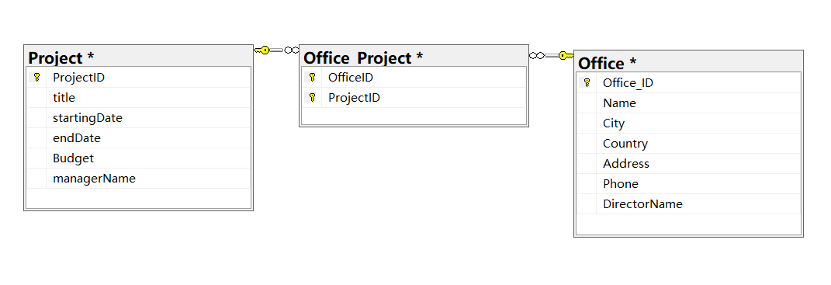

1. **Design a database for a lending company which manages lending among people (p2p lending)**

* Lenders that lending money are registered with an Id, name and available amount of money for the financial operations.
* Borrowers are identified by their id and the company registers their name and a risk value depending on their personal situation.
* When borrowers apply for a loan, a new loan code, the total amount, the refund deadline, the interest rate and its purpose are stored in database.
* Lenders choose the amount they want to invest in each loan. A lender can contribute with different partial amounts to several loans.

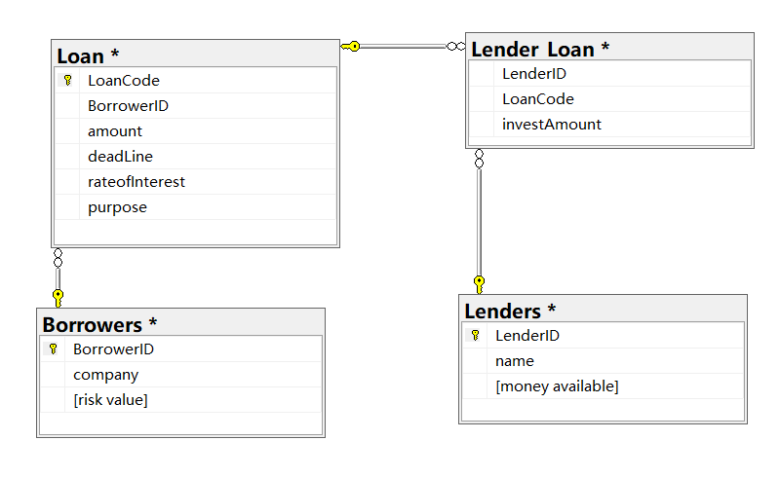

1. **Design a database to maintain the menu of a restaurant.**

* Each course has its name, a short description, photo and final price.
* Each course has categories characterized by their names, short description, name of the employee in-charge of them.
* Besides the courses some recipes are stored. They are formed by the name of their ingredients, the required amount, units of measurements and the current amount in the store.

